Our Post Masters since 1940 have been:

1940-1980 Clay Cottrell

1980-1984 Gene Stratton

1984 Jean Hollander January 4 through April 13

1984 Steve Loris April 14

**POST OFFICE BOX**

Post Office Box 141: whose mail box is this? And how long has it been used by the same family? So an interesting story goes with this Postal Box. When Clay Cottrell was moving to the new Post Office, he asked people if they wanted to keep their old box numbers or select a new one. When he asked Wanda Aldridge, they began to check how long they had used 141. She knew her great-grandfather, Thurman Hurd, and her mother, Ruth Hurd, had used the box 141. The story goes that Uncle Thurman Hurd had rented Box 141 when 'he first came to Dyer in the late 1800's, and four generations had removed mail from Box 141. He had taken letters from his two sons, Richard and Fred Hurd, when they were in Europe fighting for our freedom during World War I. He had also taken the letter out of Box 141 when he received the word that Richard Hurd had died in a hospital in Kentucky and the body would arrive home to be buried in the Dyer Cemetery.

My father, Thomas William Moss, always used P.O. Box #40 until we moved to Kansas City and when we came back after a year, we used 70 but as soon as Daddy could get #40 he rented it again and used it until he died and Mother used it until she went to live with us in 1968. I never could understand why as this was a very inconvenient box as you had to ask the Post Master to hand you the mail.

There are probably other Post Office boxes with interesting stories but no one has handed them to me.

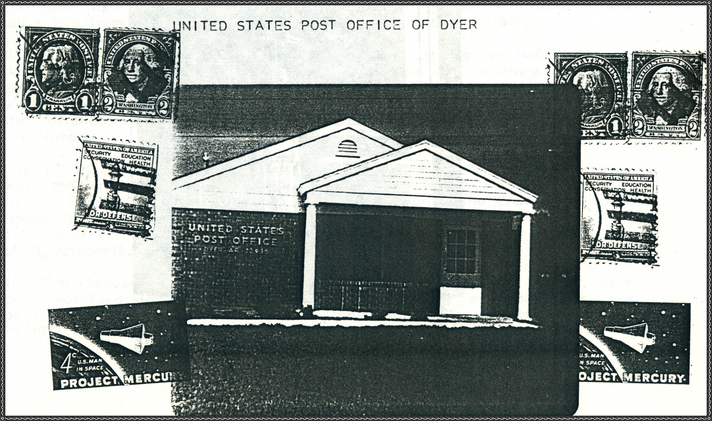

I had about seven blocks to walk to school, yet some of the children had a lot more than that far as they lived upon the mountain North of Dyer and over in the Flatwood West of Dyer. There was a large stove in the Northeast corner of the school room; this was in the four room white frame building that was built in 1902. The ones from the mountains and Flatwoods were usually at school first and would be sitting in chairs near the stove and somehow I always had a lap to sit in when I came in so cold.

Then there were the long hot summer days with no air conditioning, we didn't even know what that was, and no electric fans as we didn't have electricity in those days and the only way we had to keep cool was to use a palm leaf fan.

And not everything was "peaches and cream" for soon someone came to school with the itch and then it made the rounds and soon all in school would have it and that meant "Sulphur and Grease" doped on you and also there were those little crawly things that got on your head which were called lice.

